Class 8

**Lecture**

**23**

**HTML**



**Lab Objectives:**

* Class
* ID
* Difference between class and Id

# The class Attribute

The class attribute specifies one or more class names for an HTML element.

The class name can be used by CSS and JavaScript to perform certain tasks for elements with the specified class name.

In CSS, to select elements with a specific class, write a period (.) character, followed by the name of the class:

Follow the example and try to make another one.

**Tip:** The class attribute can be used on any HTML element.

**Note:** The class name is case sensitive!

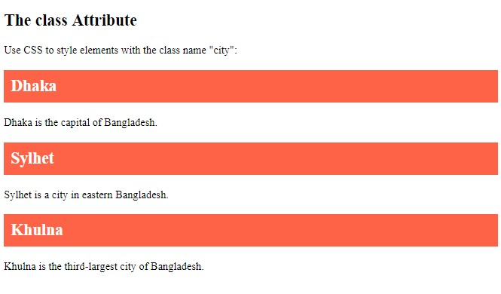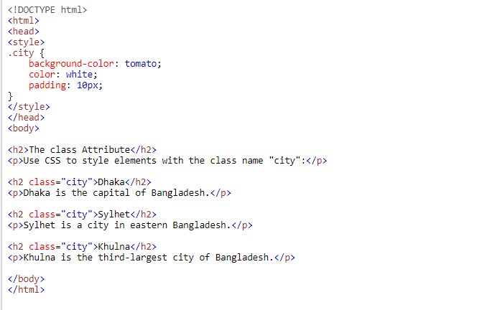

# The class Attribute in JavaScript

When a user clicks on a button, hide all elements with the class name "city":

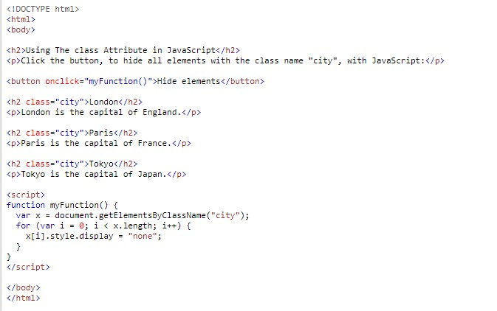

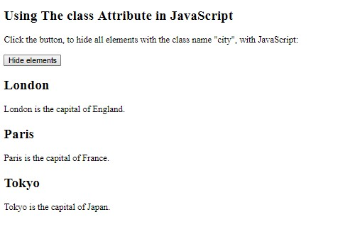

After clicking on Hide Element

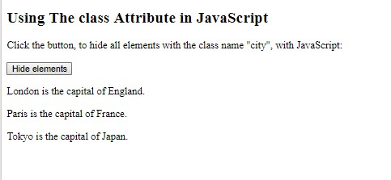

# Multiple Classes

HTML elements can have more than one class name, each class name must be separated by a space.

**Example**

Style elements with the class name "city", also style elements with the class name "main":

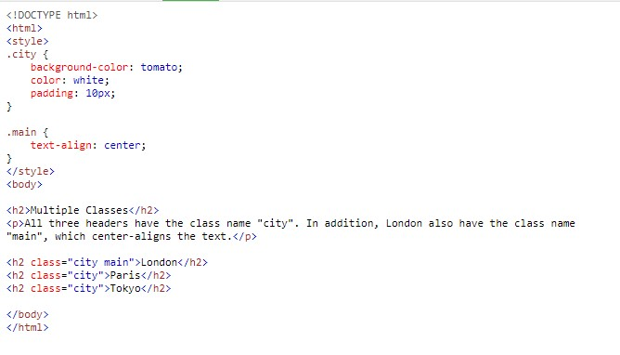

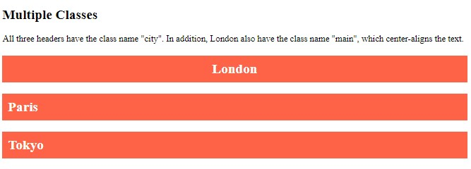

In the example above, the first <h2> element belongs to both the "city" class and the "main" class.

# Same Class, Different Tag

Different tags, like <h2> and <p>, can have the same class name and thereby share the same style:

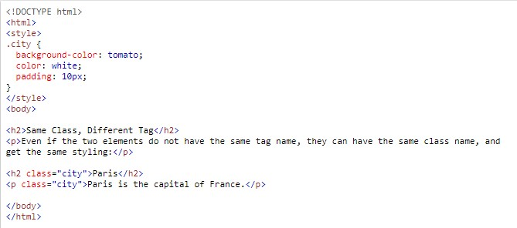

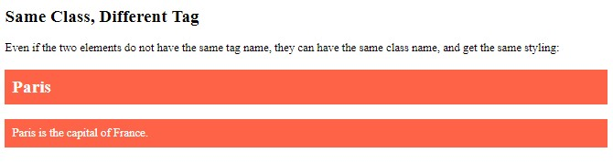

# The id Attribute

The id attribute specifies a unique id for an HTML element (the value must be unique within the HTML document).

The id value can be used by CSS and JavaScript to perform certain tasks for a unique element with the specified id value.

In CSS, to select an element with a specific id, write a hash (#) character, followed by the id of the element:

# 

**Tip:** The id attribute can be used on any HTML element.

**Note:** The id value is case-sensitive.

# Difference Between Class and ID

An HTML element can only have one unique id that belongs to that single element, while a class name can be used by multiple elements:

